BRAIN-APP DEPLOYMENT USING AWS PIPELINE,KUBERNETES,DOCKER

1.Ec2:
1.Create a ec2 instances with type as t2.Medium(since micro and nano type will not suitable for Prod)
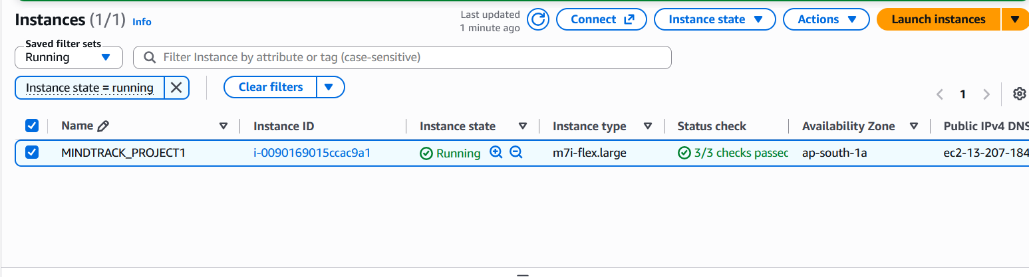
2.Create a new role with Admin Access for the Ec2 and attach it to the instance.This is for Pipeline to run without any issue and also for creating kubernetes cluster with eksctl(aws tool to create cluster from CLI).

IAM >> Roles >> create Role >> AWS service >> ec2 >> Admin acess >> ec2-role >> create

EC2 >> actions >> security >> modify IAM role >> ec2-role >> update

3.Update all thePackages in Ec2 instance.
Sudo apt update
2.Docker:
1.Install docker in the Ec2 instance.
Sudo apt install docker.io

2. Once installed the docker,run the below commands to run docker command without sudo
newgrp docker
Sudo usermod -aG docker $USER

3.Check running the docker run hello-world which fetches the hello-word image from registry.
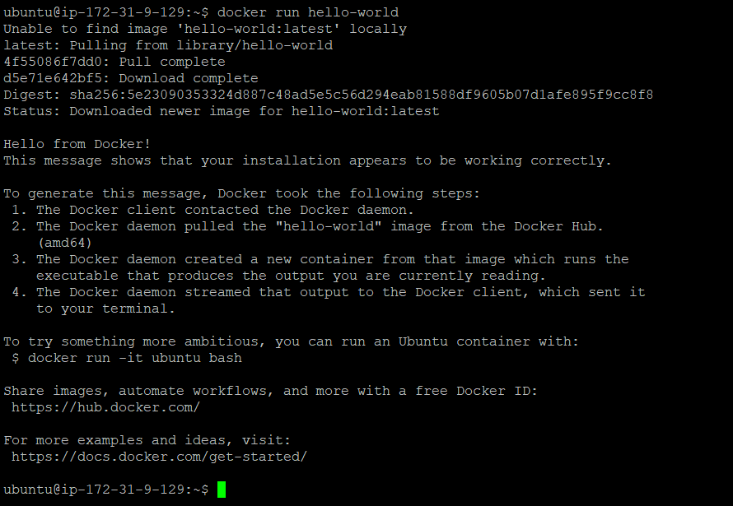

4.Clone the application from GIT location and containerize the application using Dockerfile.

git clone https://github.com/Vennilavanguvi/Brain-Tasks-App.git

Simple Docker file created for the Appliciation.
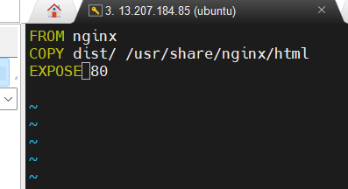
Build the application using docker build command
Run the application as docker container and verify the app is running on the Ec2 instance.

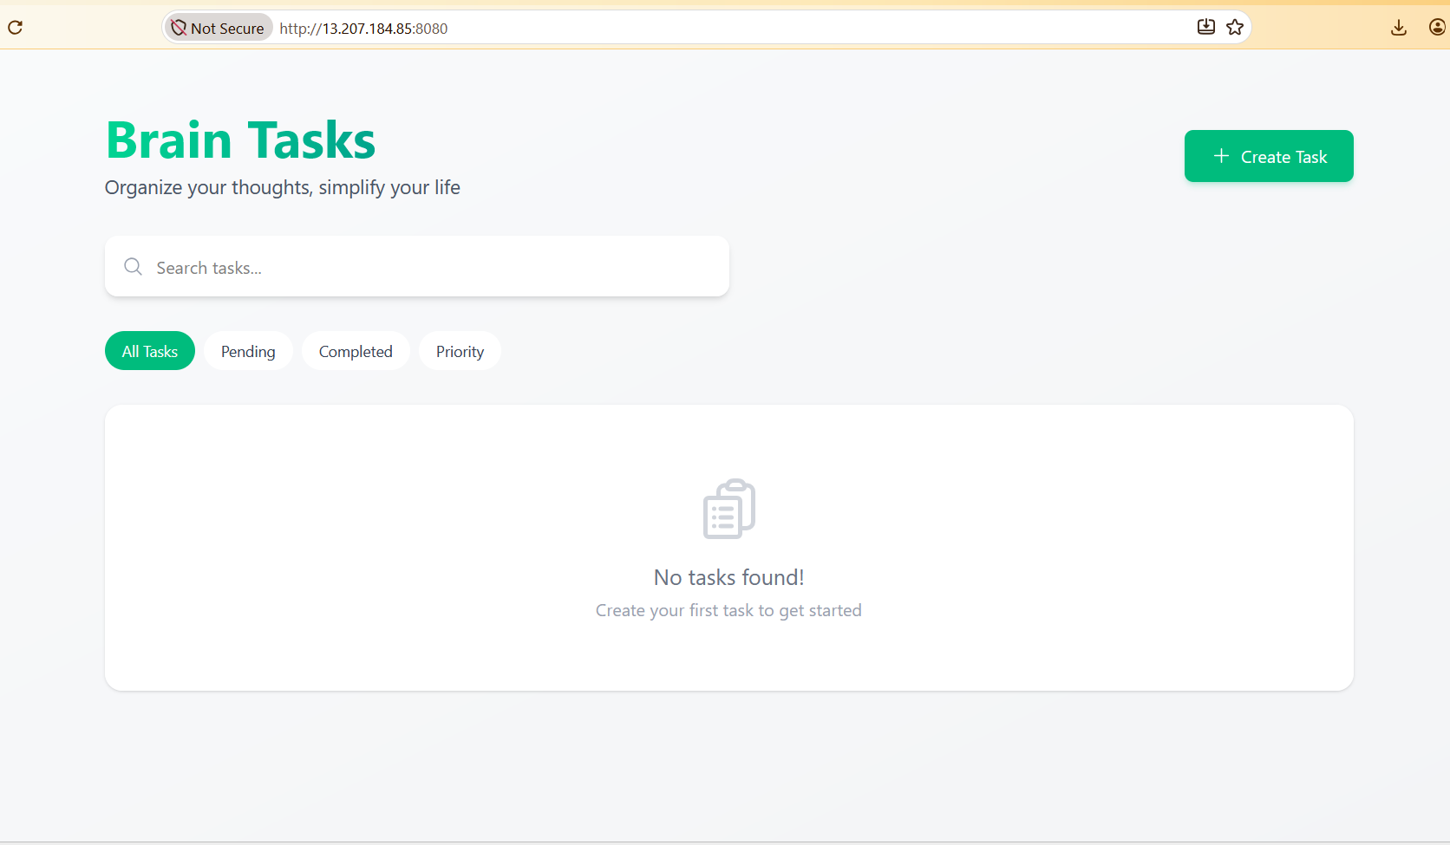
Push the image to Docker registry

docker login -u raulgandhi
docker push ragulgandhi/mindtrack

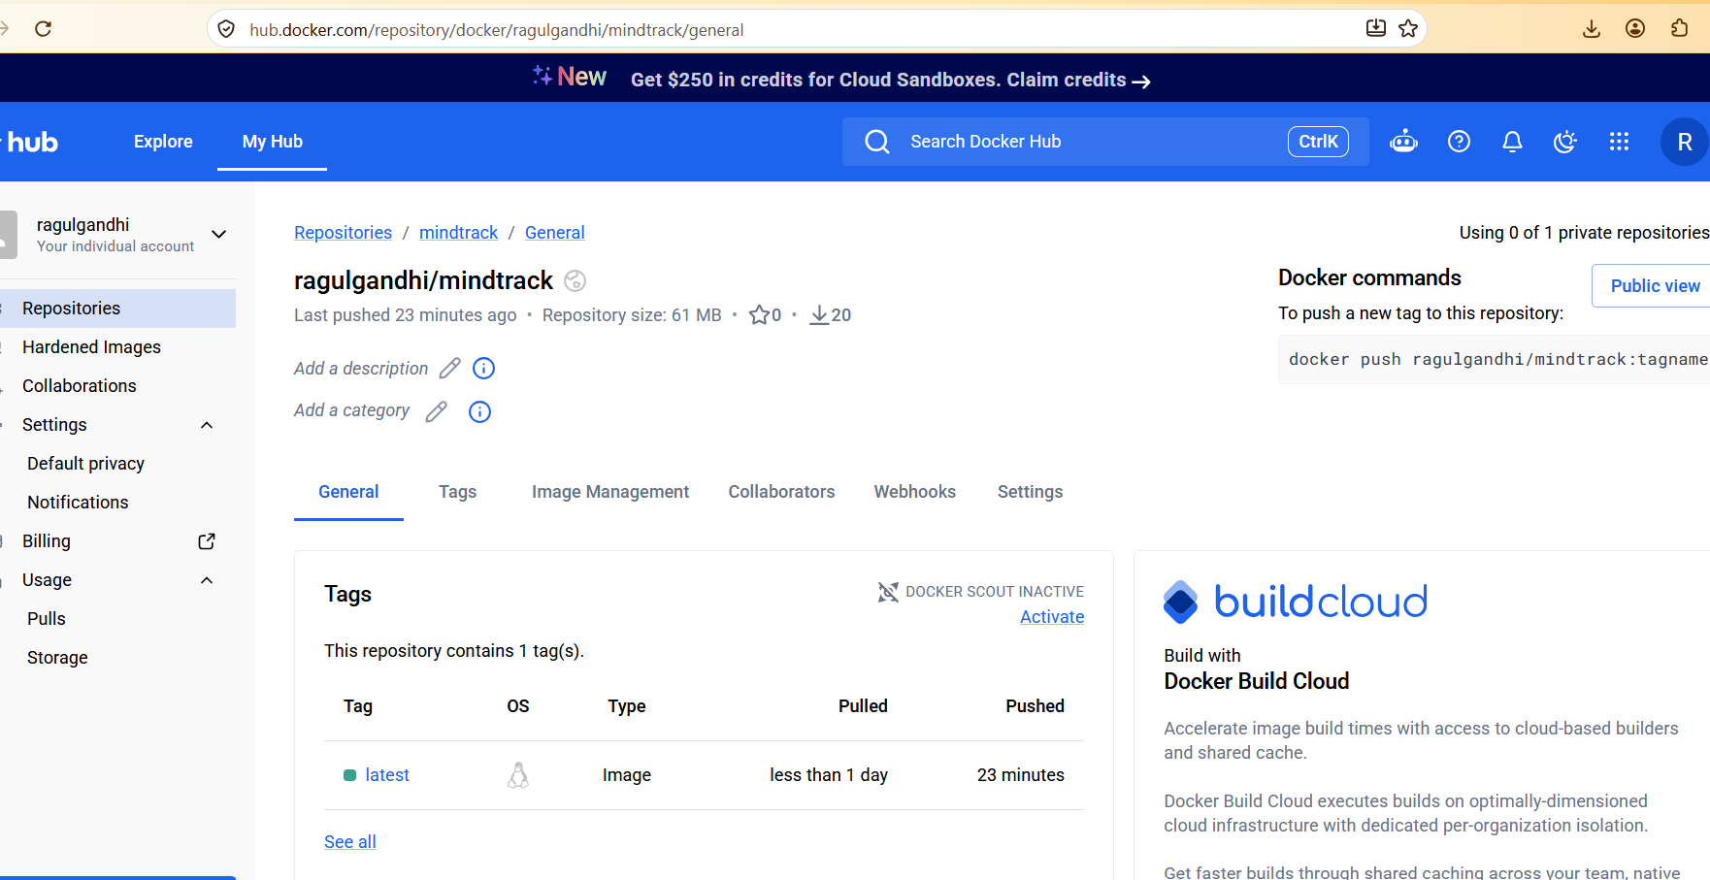

3.Kubernetes:
Install eksctl and kubectl tools for the creating and managing k8s.

Install Kubectl with the following commands:
curl -LO "https://dl.k8s.io/release/$(curl -L -s https://dl.k8s.io/release/stable.txt)/bin/linux/amd64/kubectl"

chmod +x ./kubectl

sudo mv ./kubectl /usr/local/bin.

Once installed verify the kubectl version with below command.
kubectl version –client

Eksctl:
curl --silent --location "https://github.com/weaveworks/eksctl/releases/latest/download/eksctl_$(uname -s)_amd64.tar.gz" | tar xz -C /tmp

sudo mv /tmp/eksctl /usr/local/bin
Aws cli:

Aws cli needs to installed on the Ec2 to create cluster with eksctl.use below commands to install.

sudo apt install zip -y
curl "https://awscli.amazonaws.com/awscli-exe-linux-x86_64.zip" -o "awscliv2.zip"
unzip awscliv2.zip
sudo ./aws/install

Create Eks cluster with eksctl tool and define the nodes and region for the cluster

eksctl create cluster --name ragul --region ap-south-1 --node-type m7i-flex.large --nodes 2

Once cluster is created we need to make cluster mapped with the k8s objects by using below.

aws eks update-kubeconfig --name <cluster>

Verify the cluster and nodes with below commands.

eksctl get cluster —region your region
kubectl get nodes -o wide

Kubernetes objects:
Here we create two object deployment.yml for creating pods and service.yml to expose the application with port 3000
Combining both yml as single file.

4.CI/CD Pipeline using AWS Code pipeline,Code Build,Code Deploy.

For the AWS CI/CD to work,we need to deploy aws Code deploy agent on the Worker nodes.

sudo apt update
sudo apt install wget
sudo apt install ruby-full wget
cd /home/ubuntu
wget https://bucket-name.s3.region-identifier.amazonaws.com/latestv2/install
chmod +x ./install
sudo ./install auto
systemctl status codedeploy-agent

Deploy the resources in Cluster using Kubectl apply command.

kubectl apply -f brain-app.yml

once deployed you will pods as running as below.
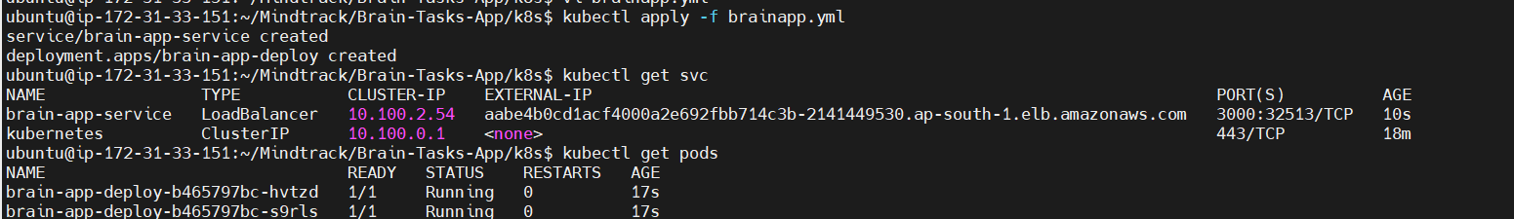

Once deployed the application ,Verify it with load balancer ingress.
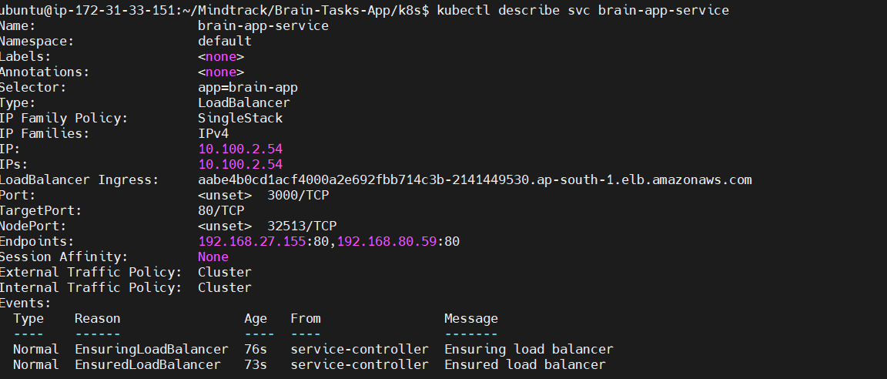

Application deployed kubernetes Loadbalancer ARN:http://aabe4b0cd1acf4000a2e692fbb714c3b-2141449530.ap-south-1.elb.amazonaws.com:3000/
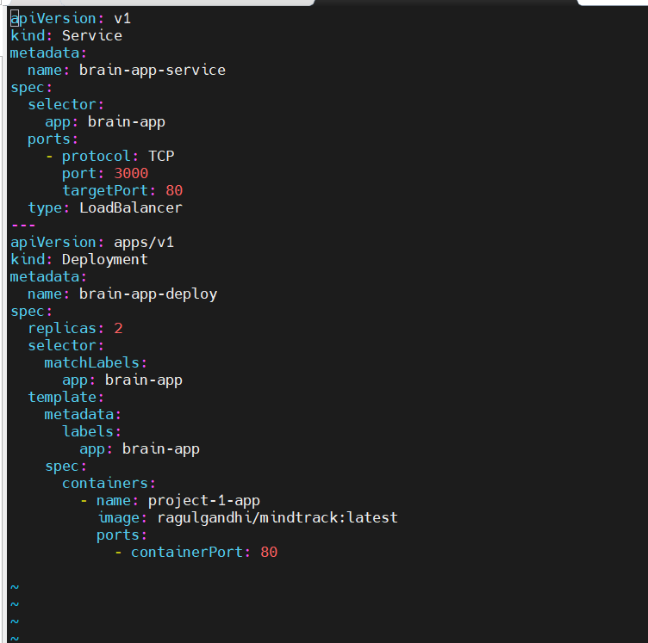
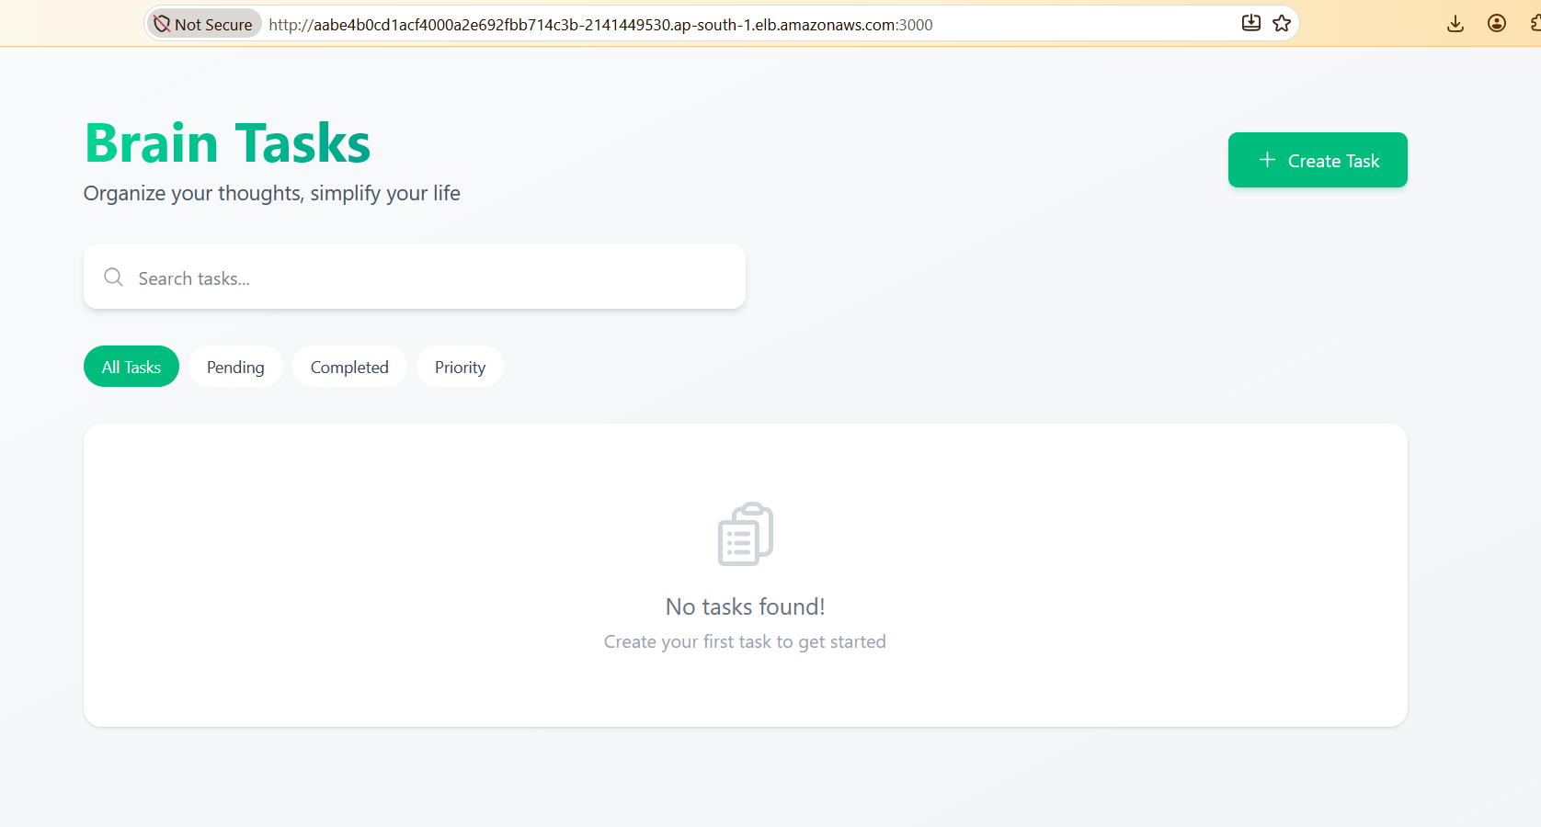
Creating CI pipeline with AWS code pipeline and AWS code Build:

Create a build spec for the image and add it to the repo .Configure code build with that buildspec.

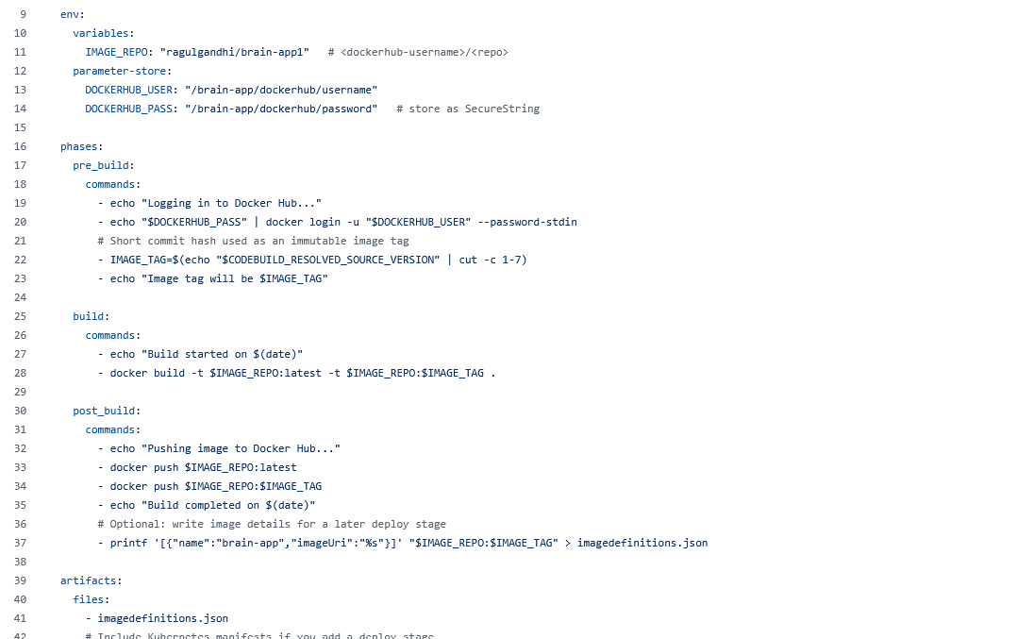

1.Docker hub credentials needs to stored on the secrets use the below commands to store password and username of the docker.

aws ssm put-parameter \
--name "/brain-app/dockerhub/username" \
--type String \
--value "ragulgandhi" \
--region ap-south-1

aws ssm put-parameter \
--name "/brain-app/dockerhub/password" \
--type SecureString \
--value "<your-docker-hub-access-token>" \
--region ap-south-1

2.Also add the below inline policy for the code build role to access the ssm keys.
{
"Effect": "Allow",
"Action": ["ssm:GetParameters", "ssm:GetParameter"],
"Resource": "arn:aws:ssm:ap-south-1:<ACCOUNT_ID>:parameter/brain-app/dockerhub/*"
}

- Add the below access entries for the code build to connect to the cluster.

aws eks create-access-entry --cluster-name ragul --region ap-south-1 \
--principal-arn arn:aws:iam::013141018784:role/service-role/codebuild-MindTrack-service-role

aws eks associate-access-policy --cluster-name ragul --region ap-south-1 \
--principal-arn arn:aws:iam::013141018784:role/service-role/codebuild-MindTrack-service-role \
--policy-arn arn:aws:eks::aws:cluster-access-policy/AmazonEKSClusterAdminPolicy \
--access-scope type=cluster

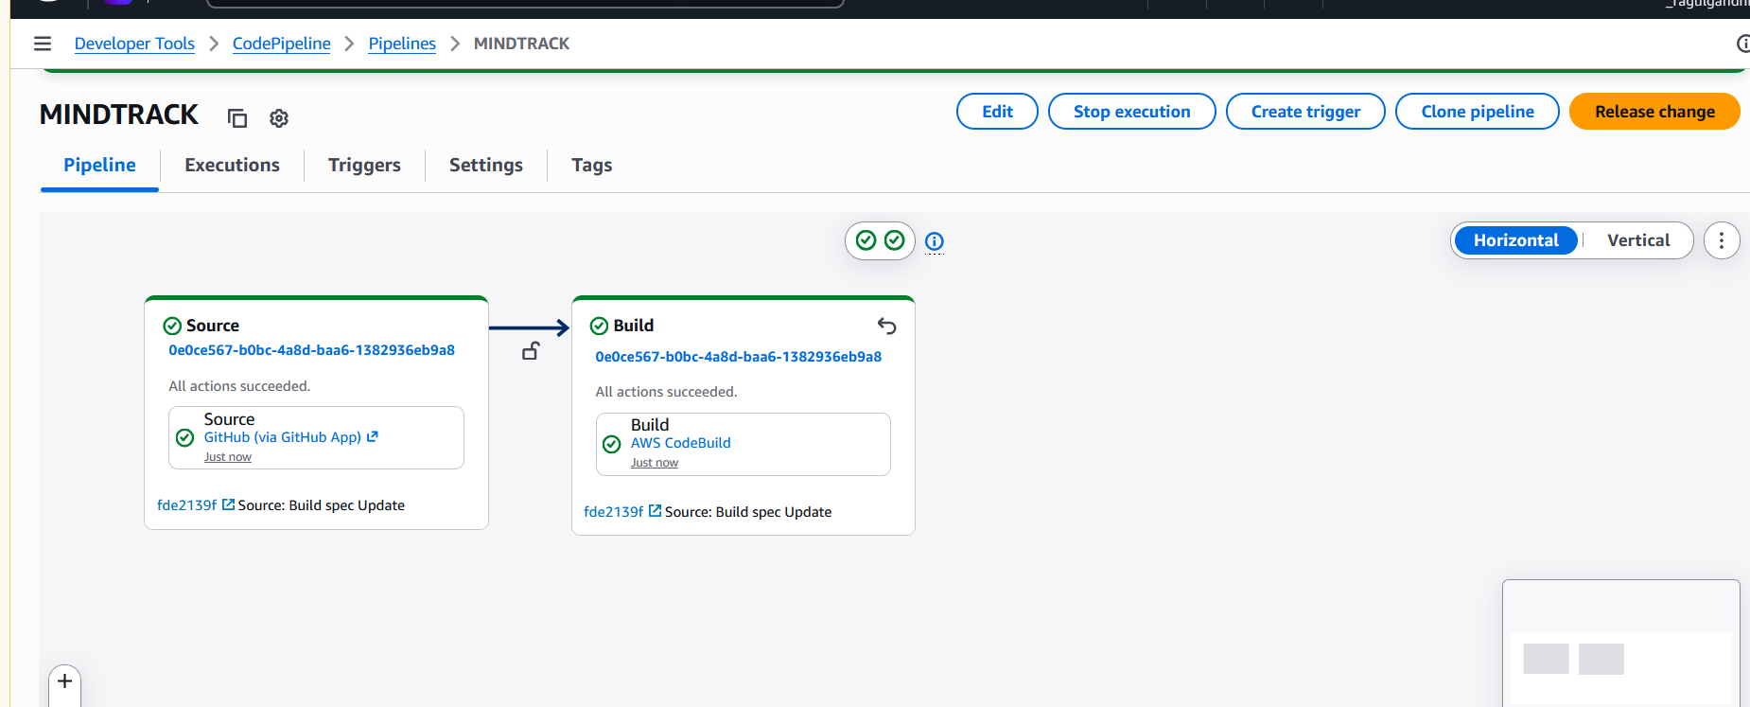

Cloud watch logs:
